**WELSC14 14,000 BTU**

**PORTABLE AIR CONDITIONER**

**USER MANUAL**

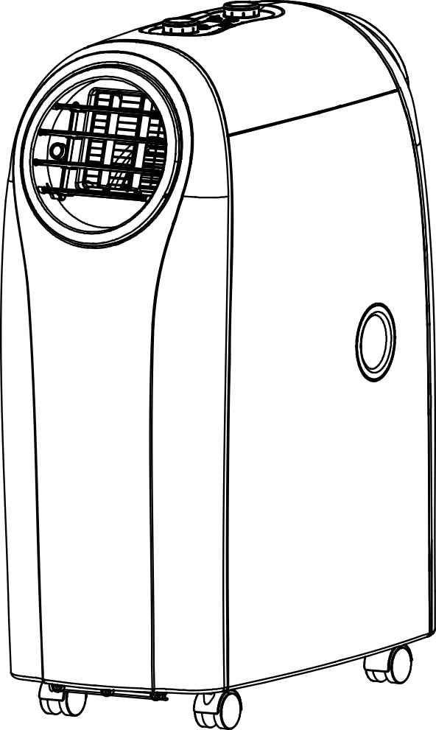

**Imported By**

Aircare Ltd.

Riverside Mill, Mountbatten Way, Congleton, Cheshire

CW12 1DY, UK

### IMPORTANT PRECAUTIONS

Read the instruction guide carefully before installing and operating this portable air conditioner.

Please retain this user manual for product warranty and future reference.

##### CAUTION

1. Allow the unit to defrost naturally. Do not use means to accelerate the defrosting process or to clean, other than those recommended by the manufacturer.
2. The appliance shall be stored in a room without continuously operating ignition sources (for example: open flames, an operating gas appliance or an operating electric heater.)
3. Do not pierce or burn.
4. Be aware that refrigerants may not contain an odour.
5. Appliance shall be installed, operated and stored in a room with a floor area larger than 13m2
6. Servicing shall be performed only as recommended by the manufacturer.
7. The appliance shall be stored in a well- ventilated area where the room size corresponds to the room area as specified for operation.
8. All working procedure that affects safety means shall only be carried by competent persons.

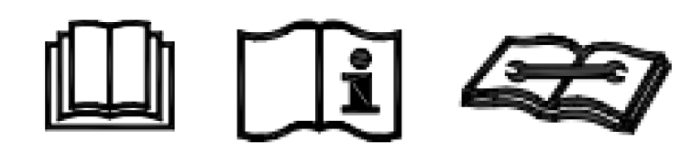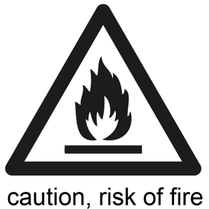

1. IMPORTANT!! Please make sure the inlet and outlet ventilation is not blocked at all times.
2. Operate this unit on a horizontal surface to avoid water leakage.
3. Do not operate this unit in an explosive or corrosive atmosphere.
4. Operate this unit in an ambient of 35 degree centigrade or less.
5. The heating function of the unit should be operated in an indoor ambient temperature between 7℃and 23℃
6. Clean the air filter periodically to enjoy the most efficient cooling.
7. When the unit is shut off, please wait at least 3.5 minutes before restarting to prevent the compressor from being damaged.
8. This unit needs at least 7 Amps of electricity to have its compressor operational. Please avoid using extension cords that may limit the required amps.
9. This unit is for indoor cooling, heating, and dehumidifying.
10. When turning on the unit, the fan will operate but the compressor will start up after the cooling alarm flashes for three minutes in heating function, the heating alarm will flash for 3.5 minutes before the compressor and fan start up.
11. When the supply cord is damaged, it must be replaced by the manufacturer, its service agent, or similarly qualified persons in order to avoid hazard.
12. To dispose of the appliance safely, please remove the batteries from the unit before scrapping it.
13. This appliance can be used by children aged from 8 years and above and persons with reduced physical, sensory, or mental capabilities or lack of experience and knowledge if they have been given supervision or instruction concerning use of the appliance in a safe way and understand the hazards involved. Children should not play with the appliance. Do not let Children clean or maintain the appliance without supervision.
14. The air-conditioner can be connected only to a supply with system impedance no more than 0.219Ω. Please consult your supply authority for system impedance information if required.
15. The appliance shall be installed in accordance with national wiring regulations.
16. Do not operate your air conditioner in a wet room such as a bathroom or laundry room.

Transportation, marking and storage for this unit.

1. Transport of equipment containing flammable refrigerants should comply with local transport regulations.
2. The item should carry the markings that comply with local regulations.
3. Disposal of equipment using flammable refrigerants should comply with national regulations.
4. The storage of equipment should be in accordance with the manufacturer’s instructions.
5. Storage packaging should be constructed such that mechanical damage to the equipment inside the package will not cause a leak of the refrigerant charge. The maximum number of pieces of equipment permitted to be stored together will be determined by local regulations.
6. The appliance shall be stored to prevent mechanical damage from occurring.
7. General work area - All maintenance staff and
   1. others working in the local area shall be instructed on the nature of work being carried out. Work in confined spaces shall be avoided. The area around the workspace shall be sectioned off. Ensure that the conditions within the area have been made safe by control of flammable material.

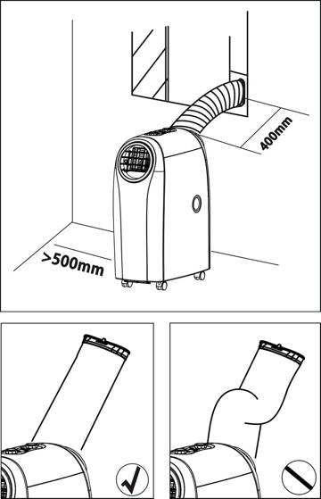

**GETTING STARTED**

For better heating and cooling efficiency, please follow the steps below:

1. Extend the exhaust hose with the length as little as possible. The exhaust hose must be kept unblocked.
2. 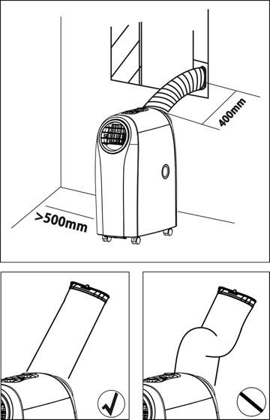A minimum distance of 500mm must be kept from the unit’s filter side to the wall or any other obstacles.
3. If the unit starts to defrost, the word “DF” shows on the LED display.

*IN ORDER TO LIFT AND RELOCATE THE MACHINE PLEASE REMOVE THE SPIGOTS/GRILLS AND PLACE YOUR HANDS UNDER THE LIP OF THE OUTLETS. PLEASE DO NOT LIFT BY THE PLASTIC SPIGOT JOINING RINGS*

*THANK YOU FOR PURCHASING   
OUR HIGH-PERFORMANCE   
PORTABLE AIR CONDITIONER*

CONGRATULATIONS

This air conditioner is designed and manufactured with the highest standards and techniques.

The unit comes with a remote control for you to operate the unit more conveniently.

WELSC14 Features:

* **High-Mobility: Moves easily from room to room with easy glide castors.**
* **Plug-to-Use: Plug and start the unit after simple installation of exhaust hose. (Follow the pictures of page 9)**
* **Strong Cooling: Powerful refrigerating system cools instantly.**
* **Clean Air Cycle: Dehumidified and filtered air improves breathing environment effectively.**
* Easy Control: Our one button pad and retro dials make this unit amongst the easier (and more fun) units to control on the market.
* **Compact Timer: 24 hours count down timer for cooling, heating and dehumidifying modes.**
* **User-Friendly “sleep mode” function**
* **Applicable power source: 220~240V/50Hz**

##### UNPACK THE UNIT

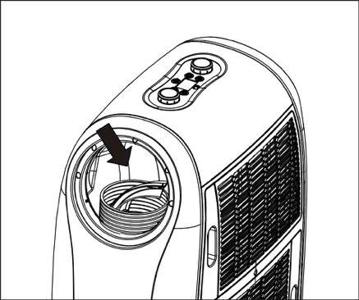1. Place the unit in upright position.

2. Cut the two packing straps.

3. Lift the outer carton slightly to release the product from the base.

4. Grip the handles on unit’s either side and carefully release the unit from the foam base.

5. Take out exhaust hose, hose adapter and nozzle

**CONTENTS**

1. Portable air conditioner unit (1 pc)
2. Remote control (1 pc)
3. Hose adapter (1 pc of each)
4. Spigot (1 pc)
5. Exhaust hose (1 pc)
6. Batteries (2 pcs)

**Remark**

**The 2nd hose kit (hose adaptor, hose, end connector) is available for selection. Please contact service in need.**

**PARTS**

1. Control panel
2. Remote control receiver
3. Control panel
4. Adjustable air vent (per-install)
5. Spigot
6. Exhaust hose
7. Upside drain hole



1. Cool air inlet
2. Cool air inlet filter
3. Hot air inlet
4. Hot air inlet filter
5. Downside drain hole
6. Hose adaptor

**HOSE ADAPTOR INSTALLATION**

Follow below steps to assemble hose adapters on the unit before operating.

**EXHAUST HOSE INSTALLATION**

1. Follow the arrow direction of picture ① to rotate the exhaust hose and remove the exhaust hose from the unit.

2. Follow the arrow direction of picture ② to rotate the exhaust hose and fix the exhaust hose firmly on the unit.

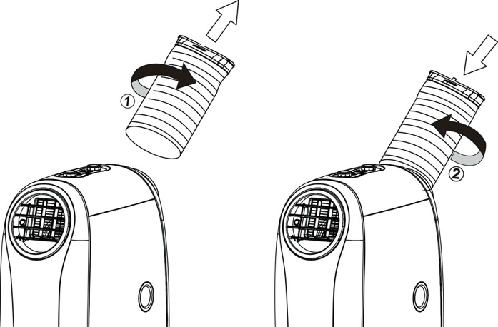

**HEATING MODE PREPARATION**

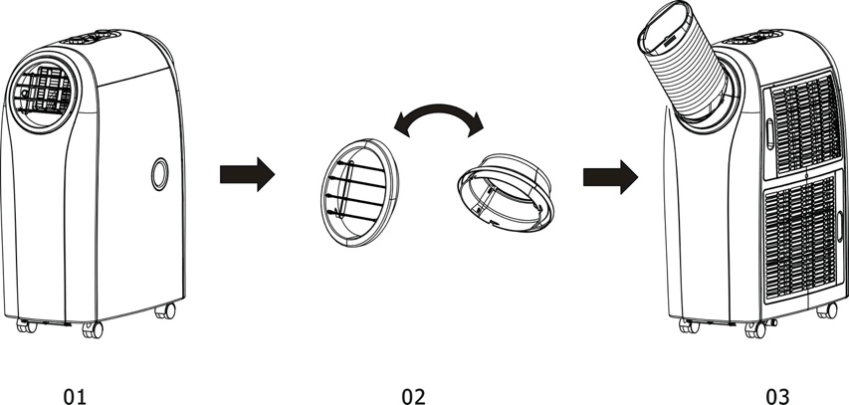

* ***To use the heating function, please follow below steps:   
  Remove and reverse the hot and cold air outlet, and re-install the air outlets as picture 03. Then, turn on the unit and switch to “Heating” mode.***

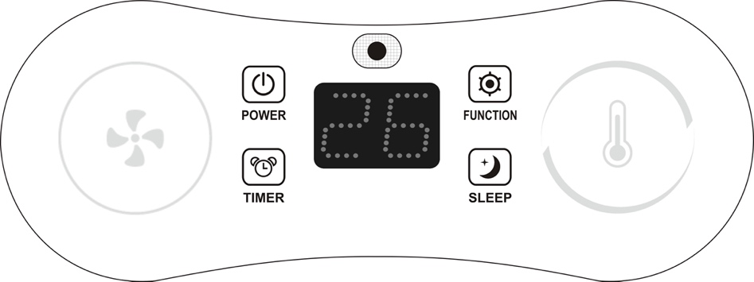**CONTROL PANEL & DESCRIPTION OF FUNCTION**

: LED DISPLAY

: POWER

: MODE

: TIMER

: SLEEP mode

**I. FUNCTIONS Key Description ：**

(1) **POWER** (On/ Off Key) :

a. Standby mode (Default)

b. Turn On/ Off the unit

◆Turn on the unit, the indicator<> lights on.

◆Turn of the unit to standby mode, the indicator<> lights off.

(2) **MODE** (Functions switch key) : the switching cycle is Cooling (Default) → Dehumidifying→ Heating, and back to Cooling again.

a. COOLING mode:

◆The indicator<> lights on。

◆The indicator<> lights in blue。

◆If the compressor shuts down, the indicator<> blinks.

◆The display<> shows setting temperature on screen.

b. DEHUMIDIFYING mode:

◆The indicator<> lights on。

◆The indicator<>lights in green.

◆If the compressor shuts down, the indicator<> blinks.

◆The display<> shows “dH” on screen.

c. HEATING mode:

◆The indicator<> lights on。

◆The indicator<> lights in red.

◆If the compressor shuts down, the indicator **<HEAT>** blinks。

◆The display<> shows setting temperature on screen.

(3) **TEMP.** (Temperature and Humidity dial):

a. COOLING / HEATING mode:

◆Rotate the dial<> in clockwise direction, the value increase 1℃/1℉ per scale. The maximum value is 30℃/86℉ (25℃/77℉).

◆Rotate the dial<> in counter-clockwise direction, the value decrease 1℃/1℉ per scale. The minimum value is 17℃/63℉(15℃/59℉).

◆While rotating the dial<>, the display<> keeps flashing. After the adjustment, the display<> shows the setting temperature.

b. DEHUMIDIFYING mode:

◆In DEHUMIDIFYING mode, the dial< > is inactive.

c. TIMER:

◆Rotate the dial<> in clockwise direction, the value +1 hour per scale.

◆Rotate the dial<> in counter-clockwise direction, the value -1 hour per scale.

◆Press the key<> before rotating the dial<>. The display<> flashes the on/ off time while setting, and shows the setting time on screen.

(4) **SPEED** (Fan speed dial) :

a. Rotate the dial<> in clockwise direction, the speed changes from Low<F1> →Mid.<F2>→High<F3>→Auto<AU)>.

b. Rotate the dial<> in counter-clockwise direction, the speed changes backwards from Auto<AU)>→High<F3>→Mid.<F2>→Low<F1>.

c. In COOLING mode, fan speeds are available from Low, Mid., and High to Auto，while the display<> shows <F1>, <F2>, <F3> and <AU> on screen.

d. Default fan speed is in medium speed<F2>。

(5) **TIMER** (Auto-On/ Auto-Off setting key) :

a. Press the key<> to activate the timer, the indicator<> lights on; press the key<> again to cancel the timer setting, ths indicator<> lights off.

b. While the unit is operating, press the key<> and rotate the dial<> to set the Auto-Off time from 0 to 24 hours.

c. While the unit is on standby, press the key<> and rotate the dial<> to set the Auto-On time from 0 to 24 hours.

d. While setting the TIMER, rotate the dial<> in clockwise/ counter-clockwise direction, the value +1/ -1 hour per scale.

e. During the TIMER mode, press and hold the key<> for 1second, the time increases continuously.

(6) **SLEEP** (SLEEP mode key) :

a. SLEEP function in COOLING mode:

◆The indicator<> lights on.

◆The setting temperature increase 1℃/ 2℉ after an hour, increase 2℃/ 4℉ after 2 hours and keeps the setting temperature unchanged.

b. SLEEP function in HEATING mode:

◆The indicator<> lights on.

◆The setting temperature decrease 1℃/ 2℉ after an hour, decrease 2℃/ 4℉ after 2 hours and keeps the setting temperature unchanged.

c. SLEEP function is inactive in DEHUMIDIFYING ING mode.

**II. STANDBY Mode ：**

In standby mode, only indicator<> and <> light in low brightness.

**III. TIMER Mode ：**

(1) TIMER scale: from 0 to 24 hours.

(2) Use the TIMER to set the Auto-Off time during operating, or set the Auto-On time in standby mode.

(3) While setting the TIMER, either the key<> or the dial<> is available to adjust the desired time.

(4) Each press of the TIMER key, the value on display<> increase from”00”→”01”……→ to”24” and back to ”00” again.

(5) Set the Auto-Off timer:

a. Press the key<> to preset the Auto-Off timer, and the display<> flashes the setting time on screen. After setting up, the display returns to show the operating mode after 5 seconds.

b. Press the key<> before the preset time to cancel the Auto-Off timer, and the unit will be turned off directly.

(6) Set the Auto-On timer:

a. While setting the Auto-On timer, you can preset the functions at the same time.

b. Press the key<> to set the Auto-On timer. After setting up, the display shows the rest of time.

c. Press the key<> before the preset time to cancel the Auto-On timer, and the unit will be turned on directly.

d. After setting up the Auto-On timer, the unit is still available to be controlled or be switched to other functions.

**IV. SLEEP Mode ：**

(1) The unit defaults not to active the SLEEP mode when electrified.

(2) SLEEP function in COOLING mode:

◆The indicator<> lights on.

◆The setting temperature increase 1℃/ 2℉ after an hour, increase 2℃/ 4℉ after 2 hours and keeps the setting temperature unchanged.

(3) SLEEP function in HEATING mode:

◆The indicator< > lights on.

◆The setting temperature decrease 1℃/ 2℉ after an hour, decrease 2℃/ 4℉ after 2 hours and keeps the setting temperature unchanged.

(4) SLEEP function is inactive in DEHUMIDIFYING ING mode.

**V. Temperature Display Switching (℃/ ℉) ：**

1. The temperature display defaults to be in Fahrenheit (**℉**).
2. In standby mode, press and hold the key< > for 5 seconds, the temperature display switches between Celsius (**℃**) and Fahrenheit (**℉**). The display flashes <**88**> once on screen with one short beep indicating the temperature is switched.

**VI. Protection ：**

1. Compressor Protection

The compressor keeps off for 3 minutes or above before restarting.

(2) Defrost Protection

(a) The display<> shows <dF> on screen.

(b) The unit defrosts when the internal temperature is too low until the internal temperature resumes. The display resume to show the functions.

(3) The display<> shows <E1> if the indoor T-round thermistor malfunctions with all the indicators lighting off and the unit shutting down. After solving the problem, the unit resumes the previous operation.

(4) The display<> shows <E2> if the indoor T-coil thermistor malfunctions with all the indicators lighting off and the unit shutting down. After solving the problem, the unit resumes the previous operation.

(5) Water Full Protection

(a) The display<> shows <E4> on screen.

(b) The unit stops working when the water is full with <E4> shows on screen. After solving the problem, the unit resume standby. Press the key<> to restart.

**REMOTE CONTROL FUNCTION**

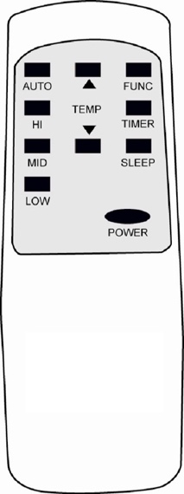

**1. POWER**

**2. FUNC**

**3. TIMER**

**4. AUTO**

**5. HI**

**6. MID**

**7. LOW**

**8. SLEEP**

**9. TEMP.**

**On/Off switch**

**Function “MODE” selector**

**Hourly programming**

**Automatic fan speed**

**High fan speed**

**Medium fan speed**

**Low fan speed**

**Night operation selector**

**Temperature selector**

**IMPORTANT MESSAGES**

**The unit evaporates the condensation and distribute through the exhaust hose.**

1. In COOLING mode, it is not necessary to install the drainpipe. Please ensure the rubber cap is locked on the drain hole when the unit is operating.

2. In HEATING mode, please pull out the rubber cap ① to install the drainpipe to keep the best heating efficiency.

3. In DEHUMIFIFYING mode, please pull out the rubber cap ① to install the drainpipe, and remove the exhaust hose to keep the best dehumidifying efficiency.

※ When the water tank is full, the display<> shows <E4> on screen. Please remove the rubber cap ② of the bottom drain hole to release the water. After the drainage, press power to restart the unit.

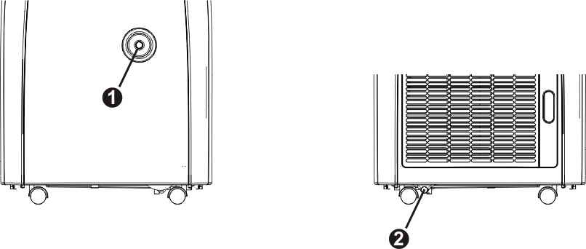

**MAINTENANCE**

PLEASE DISCONNECT THE POWER CORD BEFORE CLEANING.

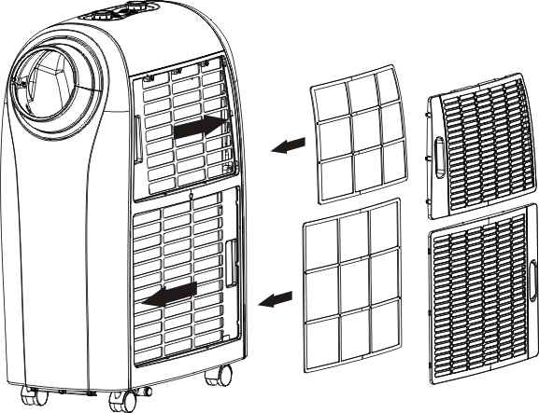

**Air Filters**

The air filters located at the left-hand side of the unit.   
Simply removed by pulling the frame out through the arrow’s direction

**Condenser/ Evaporator**

Use a vacuum cleaner with brush.

**Plastic Case**

Wipe with a damp cloth and polish with a soft cloth.

**POWER SUPPLY**

1. Be sure to connect to the correct power supply.

2. Insert the plug into the outlet firmly.

3. Never pull power cable by force, or the cable may be damaged.

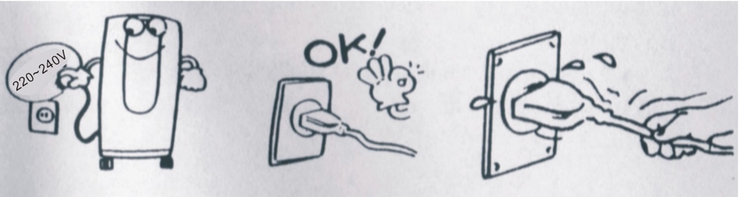**PLACE FOR USE**

1. Please place the unit in a wide and ventilated place, ensuring that the exhaust is not restricted in any way.

2. Never place the unit in water or wet place to avoid the danger of electricity leakage.

3. Do not place the unit in sunlit corner, otherwise the unit might be overheated and shut down. Besides, the color of the machine may change or fade out.

**HELPFUL HINTS**

The unit is fitted with a special thermal cut off device.  
Please ensure the unit is not placed against any objects (e.g. furniture or curtain). Obstructing air inlet may affect the performance dramatically.

*IN ORDER TO LIFT AND RELOCATE THE MACHINE PLEASE REMOVE THE SPIGOTS/GRILLS AND PLACE YOUR HANDS UNDER THE LIP OF THE OUTLETS. PLEASE DO NOT LIFT BY THE PLASTIC SPIGOT JOINING RINGS*

**Troubleshooting**

**1. Information on servicing**

1) Checks to the area

Prior to beginning work on systems containing flammable refrigerants, safety checks are necessary to ensure that the risk of ignition is minimised. For repair to the refrigerating system, the following precautions shall be complied with prior to conducting work on the system.

2) Work procedure

Work shall be undertaken under a controlled procedure to minimise the risk of a flammable gas or vapour being present while the work is being performed.

3) Checking for presence of refrigerant

The area shall be checked with an appropriate refrigerant detector prior to and during work, to ensure the technician is aware of potentially flammable atmospheres. Ensure that the leak detection equipment being used is suitable for use with flammable refrigerants, i.e. non-sparking, adequately sealed or intrinsically safe.

4) Presence of fire extinguisher

If any hot work is to be conducted on the refrigeration equipment or any associated parts, appropriate fire extinguishing equipment shall be available to hand. Have a dry powder or CO2 fire extinguisher adjacent to the charging area.

5) No ignition sources

No person carrying out work in relation to a refrigeration system which involves exposing any pipe work that contains or has contained flammable refrigerant shall use any sources of ignition in such a manner that it may lead to the risk of fire or explosion. All possible ignition sources, including cigarette smoking, should be kept sufficiently far away from the site of installation, repairing, removing and disposal, during which flammable refrigerant can possibly be released to the surrounding space. Prior to work taking place, the area

around the equipment is to be surveyed to make sure that there are no flammable hazards or ignition risks. “No Smoking” signs shall be displayed.

6) Ventilated area

Ensure that the area is in the open or that it is adequately ventilated before breaking into the system or conducting any hot work. A degree of ventilation shall continue during the period that the work is carried out. The ventilation should safely disperse any released refrigerant and preferably expel it externally into the atmosphere.

7) Checks to the refrigeration equipment

Where electrical components are being changed, they shall be fit for the purpose and to the correct specification. At all times the manufacturer’s maintenance and service guidelines shall be followed. If in doubt consult the manufacturer’s technical department for assistance.

The following checks shall be applied to installations using flammable refrigerants:

* + The charge size is in accordance with the room size within which the refrigerant containing parts are installed;
  + The ventilation machinery and outlets are operating adequately and are not obstructed;
  + If an indirect refrigerating circuit is being used, the secondary circuit shall be checked for the presence of refrigerant;
  + Marking to the equipment continues to be visible and legible. Markings and signs that are illegible shall be corrected;
  + Refrigeration pipe or components are installed in a position where they are unlikely to be exposed to any substance which may corrode refrigerant containing components, unless the components are constructed of materials which are inherently resistant to being corroded or are suitably protected against being so corroded.

8) Checks to electrical devices

Repair and maintenance to electrical components shall include initial safety checks and component inspection procedures. If a fault exists that could compromise safety, then no electrical supply shall be connected to the circuit until it is satisfactorily dealt with. If the fault cannot be corrected immediately but it is necessary to continue operation, an adequate temporary solution shall be used. This shall be reported to the owner of the equipment so all parties are advised.

Initial safety checks shall include:

* + - That capacitors are discharged: this shall be done in a safe manner to avoid possibility of sparking;
    - That there no live electrical components and wiring are exposed while charging, recovering or purging the system;
    - That there is continuity of earth bonding.

1. **Repairs to sealed components**

1) During repairs to sealed components, all electrical supplies shall be disconnected from the equipment being worked upon prior to any removal of sealed covers, etc. If it is absolutely. necessary to have an electrical supply to equipment during servicing, then a permanently operating form of leak detection shall be located at the most critical point to warn of a potentially hazardous situation.

2) Particular attention shall be paid to the following to ensure that by working on electrical components, the casing is not altered in such a way that the level of protection is affected. This shall include damage to cables, excessive number of connections, terminals not made to original specification, damage to seals, incorrect fitting of glands, etc.

Ensure that apparatus is mounted securely.

Ensure that seals or sealing materials have not degraded such that they no longer serve the purpose of preventing the ingress of flammable atmospheres. Replacement parts shall be in accordance with the manufacturer’s specifications.

**NOTE:** The use of silicon sealant may inhibit the effectiveness of some types of leak

detection equipment. Intrinsically safe components do not have to be isolated prior to working on them.

**3. Repair to intrinsically safe components**

Do not apply any permanent inductive or capacitance loads to the circuit without ensuring that this will not exceed the permissible voltage and current permitted for the equipment in use.

Intrinsically safe components are the only types that can be worked on while live in the presence of a flammable atmosphere. The test apparatus shall be at the correct rating. Replace components only with parts specified by the manufacturer. Other parts may result in the ignition of refrigerant in the atmosphere from a leak.

**4. Cabling**

Check that cabling will not be subject to wear, corrosion, excessive pressure, vibration, sharp edges, or any other adverse environmental effects. The check shall also consider the effects of aging or continual vibration from sources such as compressors or fans.

**5. Detection of flammable refrigerants**

Under no circumstances shall potential sources of ignition be used in the searching for or detection of refrigerant leaks. A halide torch (or any other detector using a naked flame) shall not be used.

**6. Leak detection methods**

The following leak detection methods are deemed acceptable for systems containing flammable refrigerants.

Electronic leak detectors shall be used to detect flammable refrigerants, but the

sensitivity may not be adequate or may need re-calibration. (Detection equipment shall be calibrated in a refrigerant-free area.) Ensure that the detector is not a potential source of ignition and is suitable for the refrigerant used. Leak detection equipment shall be set at a percentage of the LFL of the refrigerant and shall be calibrated to the refrigerant employed and the appropriate percentage of gas (25 % maximum) is confirmed.

Leak detection fluids are suitable for use with most refrigerants but the use of

detergents containing chlorine shall be avoided as the chlorine may react with the

refrigerant and corrode the copper pipework.

If a leak is suspected, all naked flames shall be removed/ extinguished.

If a leakage of refrigerant is found which requires brazing, all of the refrigerant should be recovered from the system, or isolated (by means of shut off valves) in a part of the system remote from the leak. Oxygen free nitrogen (OFN) shall then be purged through the system both before and during the brazing process.

1. **Removal and evacuation**

When breaking into the refrigerant circuit to make repairs – or for any other purpose –conventional procedures shall be used. However, it is important that best practice is followed since flammability is a consideration. The following procedure shall be adhered to:

• Remove refrigerant.

• Purge the circuit with inert gas.

• Evacuate.

• Purge again with inert gas.

• Open the circuit by cutting or brazing.

The refrigerant charge shall be recovered into the correct recovery cylinders. The system shall be “flushed” with OFN to render the unit safe. This process may need to be repeated several times. Compressed air or oxygen shall not be used for this task. Flushing shall be achieved by breaking the vacuum in the system with OFN and continuing to fill until the working pressure is achieved, then venting to atmosphere, and finally pulling down to a vacuum. This process shall be repeated until no refrigerant is within the system. When the final OFN charge is used, the system shall be vented down to atmospheric pressure to enable work to take place. This operation is absolutely vital if brazing operations on the pipe-work are to take place. Ensure that the outlet for the vacuum pump is not close to any ignition sources and there is ventilation available.

1. **Charging procedures**

In addition to conventional charging procedures, the following requirements shall be

followed.

* Ensure that contamination of different refrigerants does not occur when using charging equipment. Hoses or lines shall be as short as possible to minimise the amount of refrigerant contained in them.
* Cylinders shall be kept upright.
* Ensure that the refrigeration system is earthed prior to charging the system with refrigerant.
* Label the system when charging is complete (if not already).
* Extreme care shall be taken not to overfill the refrigeration system. Prior to recharging the system it shall be pressure tested with OFN. The system shall be leak tested on completion of charging but prior to commissioning. A follow up leak test shall be carried out prior to leaving the site.

**9. Decommissioning**

Before carrying out this procedure, it is essential that the technician is completely familiar with the equipment and all its detail. It is recommended good practice that all refrigerants are recovered safely. Prior to the task being carried out, an oil and refrigerant sample shall be taken in case analysis is required prior to re-use of reclaimed refrigerant. It is essential that electrical power is available before the task is commenced.

* 1. Become familiar with the equipment and its operation.
  2. Isolate system electrically.
  3. Before attempting the procedure ensure that: Mechanical handling equipment is available, if required, for handling refrigerant cylinders;
* All personal protective equipment is available and being used correctly;
* The recovery process is supervised at all times by a competent person;
* Recovery equipment and cylinders conform to the appropriate standards.
  1. Pump down refrigerant system, if possible.
  2. If a vacuum is not possible, make a manifold so that refrigerant can be removed from various parts of the system.
  3. Make sure that cylinder is situated on the scales before recovery takes place.
  4. Start the recovery machine and operate in accordance with manufacturer's instructions.
  5. Do not overfill cylinders. (No more than 80 % volume liquid charge).
  6. Do not exceed the maximum working pressure of the cylinder, even temporarily.
  7. When the cylinders have been filled correctly and the process completed, make sure that the cylinders and the equipment are removed from site promptly and all isolation valves on the equipment are closed off.
  8. Recovered refrigerant shall not be charged into another refrigeration system unless it has been cleaned and checked.

**10. Labelling**

Equipment shall be labelled stating that it has been de-commissioned and emptied of refrigerant. The label shall be dated and signed. Ensure that there are labels on the equipment stating the equipment contains flammable refrigerant.

**11. Recovery**

When removing refrigerant from a system, either for servicing or decommissioning, it is recommended good practice that all refrigerants are removed safely.

When transferring refrigerant into cylinders, ensure that only appropriate refrigerant recovery cylinders are employed. Ensure that the correct number of cylinders for holding the total system charge is available. All cylinders to be used are designated for the recovered refrigerant and labelled for that refrigerant (i.e. special cylinders for the recovery of refrigerant). Cylinders shall be complete with pressure relief valve and associated shut-off valves in good working order. Empty recovery cylinders are evacuated and, if possible, cooled before recovery occurs.

The recovery equipment shall be in good working order with a set of instructions

concerning the equipment that is at hand and shall be suitable for the recovery of

flammable refrigerants. In addition, a set of calibrated weighing scales shall be available and in good working order. Hoses shall be complete with leak-free disconnect couplings and in good condition. Before using the recovery machine, check that it is in satisfactory working order, has been properly maintained and that any associated electrical components are sealed to prevent ignition in the event of a refrigerant release. Consult manufacturer if in doubt.

The recovered refrigerant shall be returned to the refrigerant supplier in the correct

recovery cylinder, and the relevant Waste Transfer Note arranged. Do not mix

refrigerants in recovery units and especially not in cylinders.

If compressors or compressor oils are to be removed, ensure that they have been evacuated to an acceptable level to make certain that flammable refrigerant does not remain within the lubricant. The evacuation process shall be carried out prior to returning the compressor to the suppliers. Only electric heating to the compressor body shall be employed to accelerate this process. When oil is drained from a system, it shall be carried out safely.

**Fuse parameters of the machine**

Type: 5H or 524 Voltage: 250V Current: 3.15 A

**TROUBLE SHOOTING**

|  |  |  |
| --- | --- | --- |
| **Code** | **Cause of Problem** | **Solution** |
| E1 | Electrical short on rubber temperature sensor and PCB | Contact an electrician for repair |
| E2 | Electrical short on copper temperature sensor and PCB | Contact an electrician for repair |
| E4 | Water plate is full | Pull out the rubber stopper located at the bottom of the unit to drain the water out. |

**SPECIFICATION**

|  |  |
| --- | --- |
| Model No. | WELSC14 |
| Power Source | 220~240V-50Hz |
| Rated Power  Cooling  Heating | 1535W  1290W |
| Cooling Capacity | 4000W (14000BTU) |
| Heating Capacity | 4000W |
| Moisture Removed | 70 Liters/day |
| Refrigerant | R290, 0.27kg |
| Permissible Excessive Operating Pressure | |
| Suction: | 0.6MPa |
| Discharge: | 2.5MPa |
| Maximum allowable pressure | 5.0MPa |
| Dimensions (mm) | 330Wx550Dx790H |
| Weight (kg) | 30 |

|  |
| --- |
| This marking indicates that this product should not be disposed with other household wastes throughout the EU. To prevent possible hazards to the environment or human health from uncontrolled waste disposal, please recycle it to prove the sustainable reuse of material resources. Please ask return and collection systems or contact the retailer where the product was purchased to return your used device, they can recycle products safely. |

